Assingment 1: Docker : Created docker assignment repositories and created 3 diff Branches accordingly 2026-Q1 . 2026-Q2, 2026-Q3 and Created Jenkinsfile inside main branch and added pipeline script inside jenkinsfile.\
Github repository.
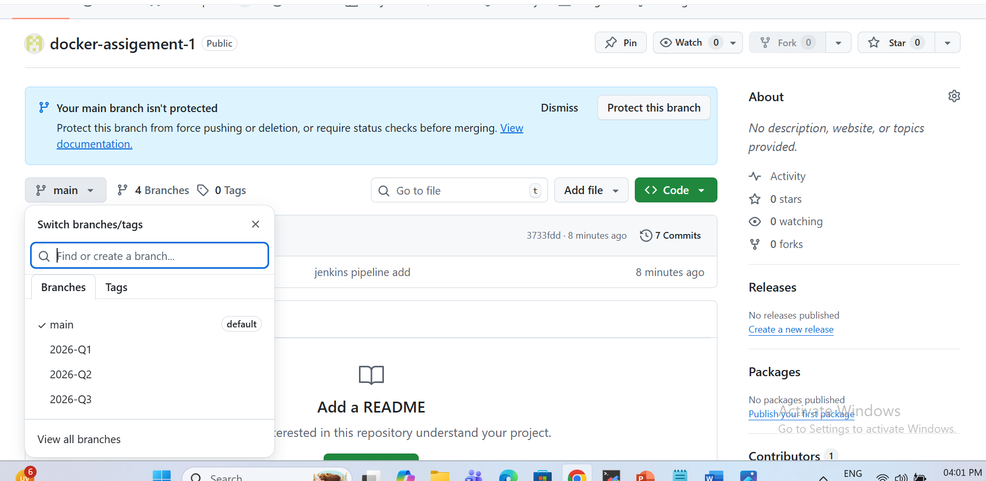

2. Jenkinsfile Pipeline script for main Branch
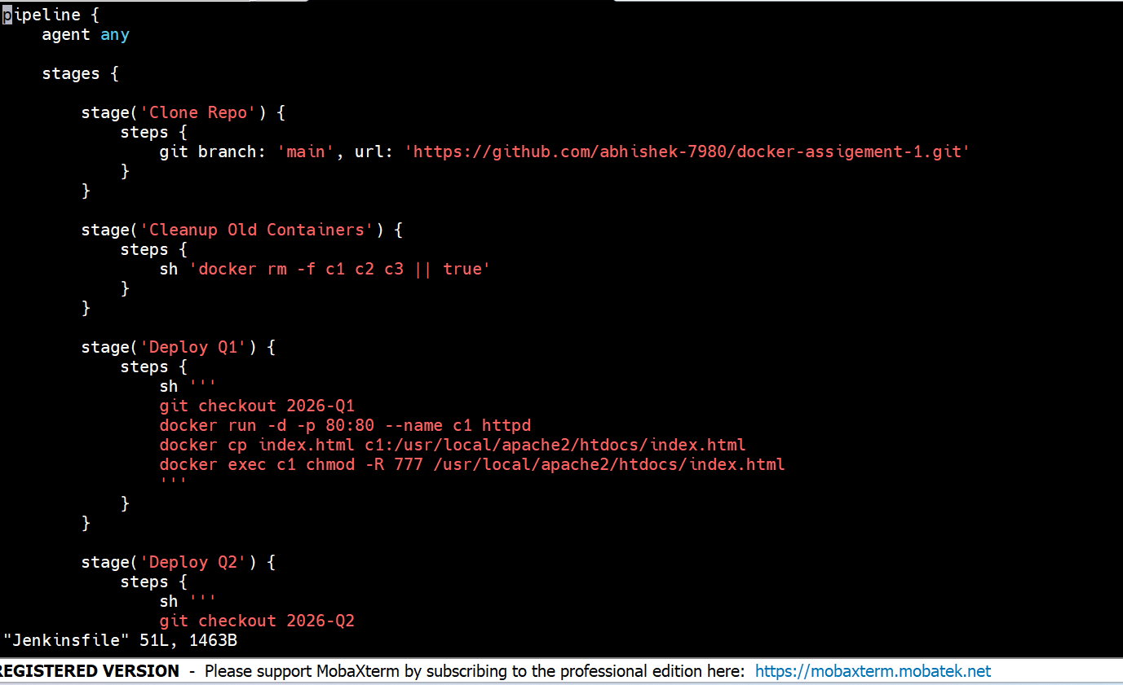

3. Jenkins Job
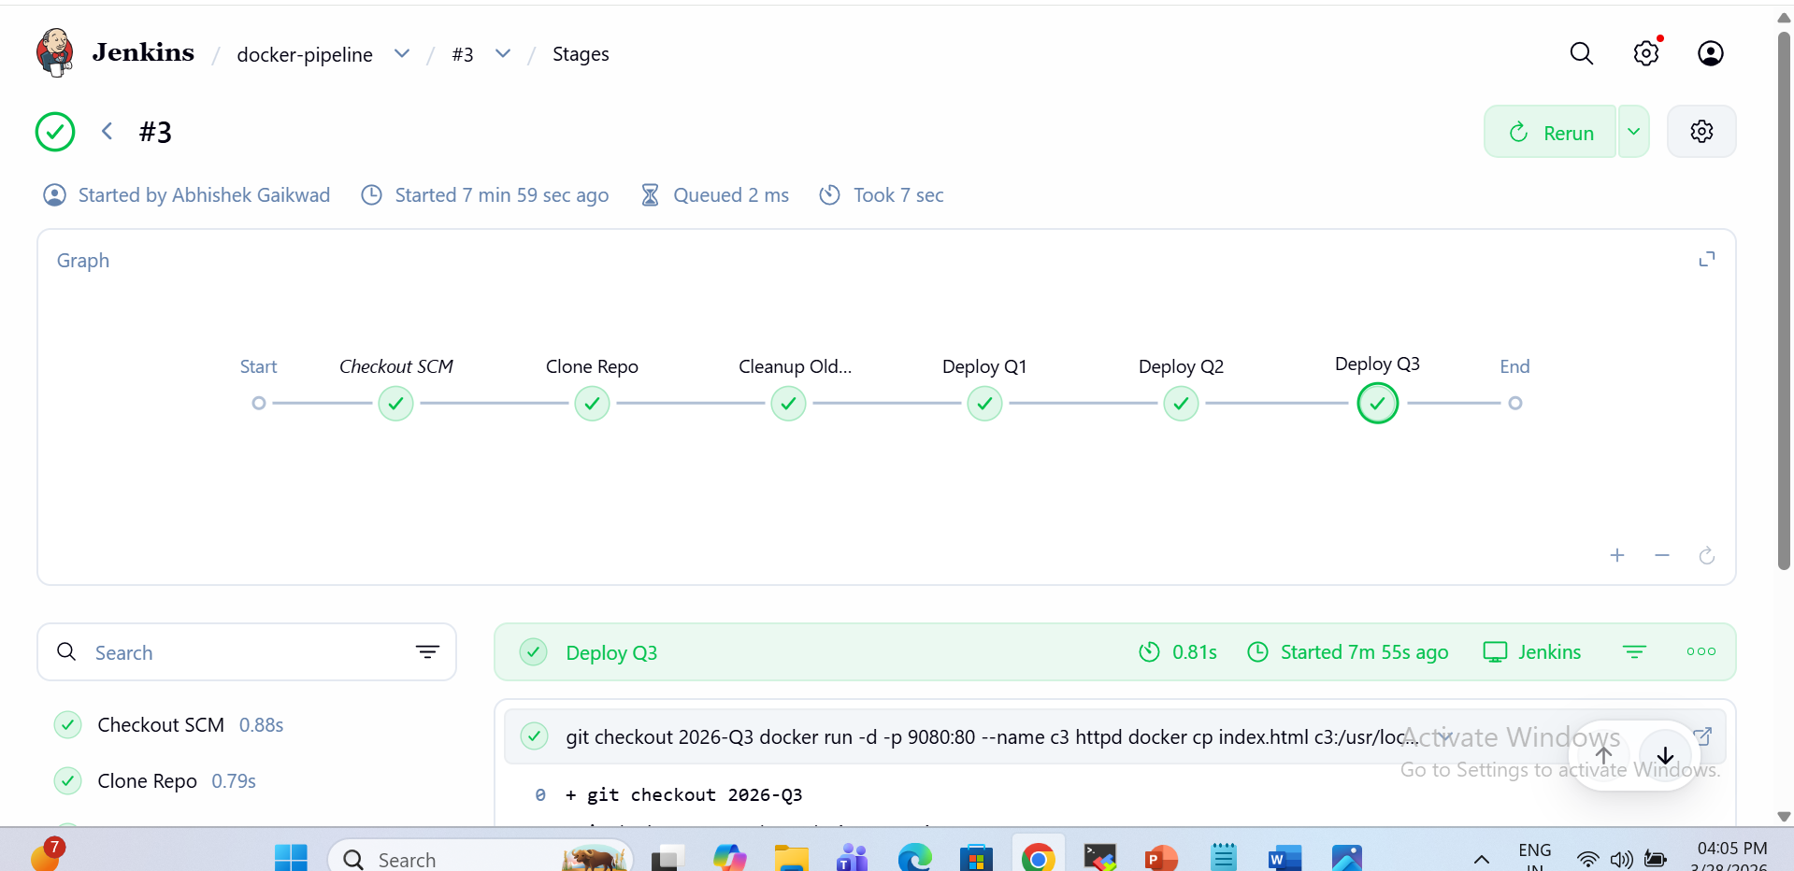
4. Docker container
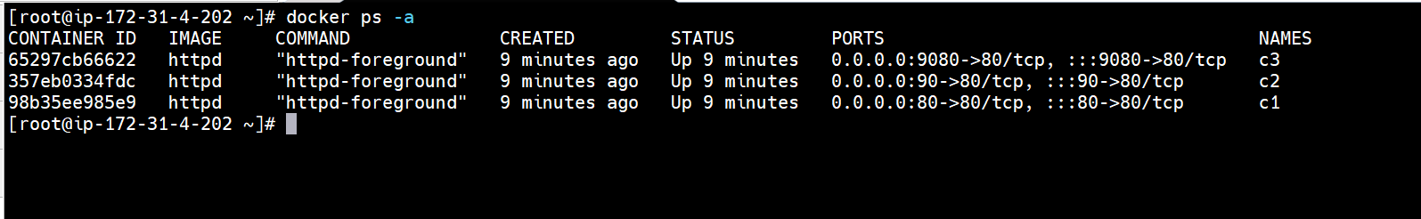
5.Using Jenkinsfile script path
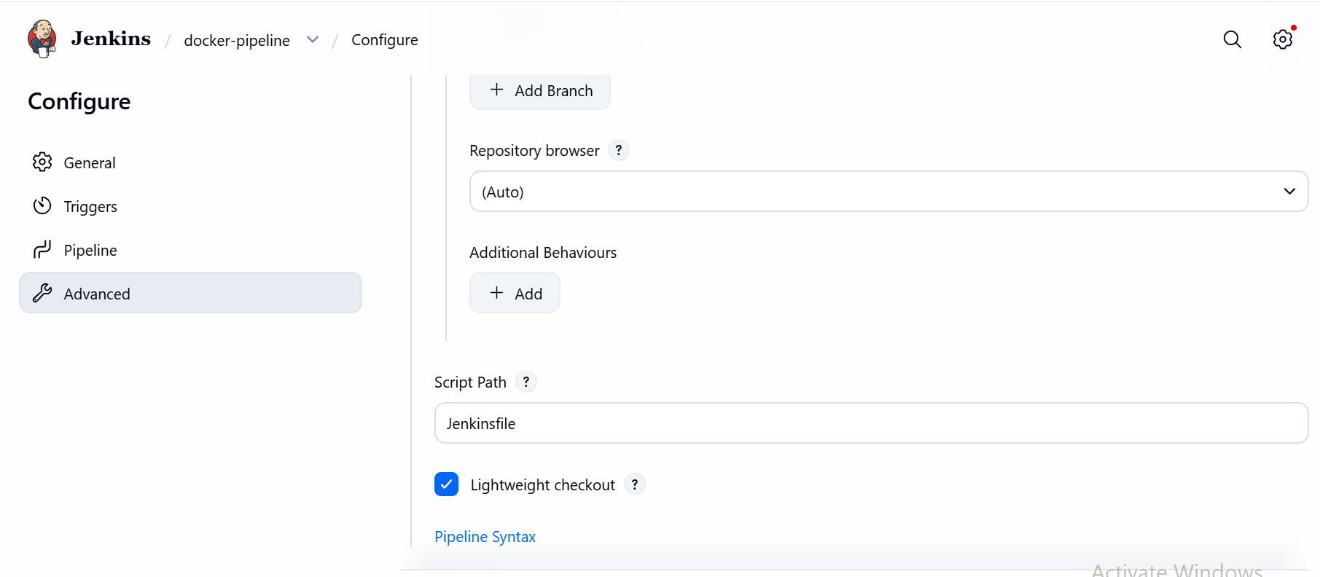

6. Using definition as a pipeline script for SCM – git and repository url

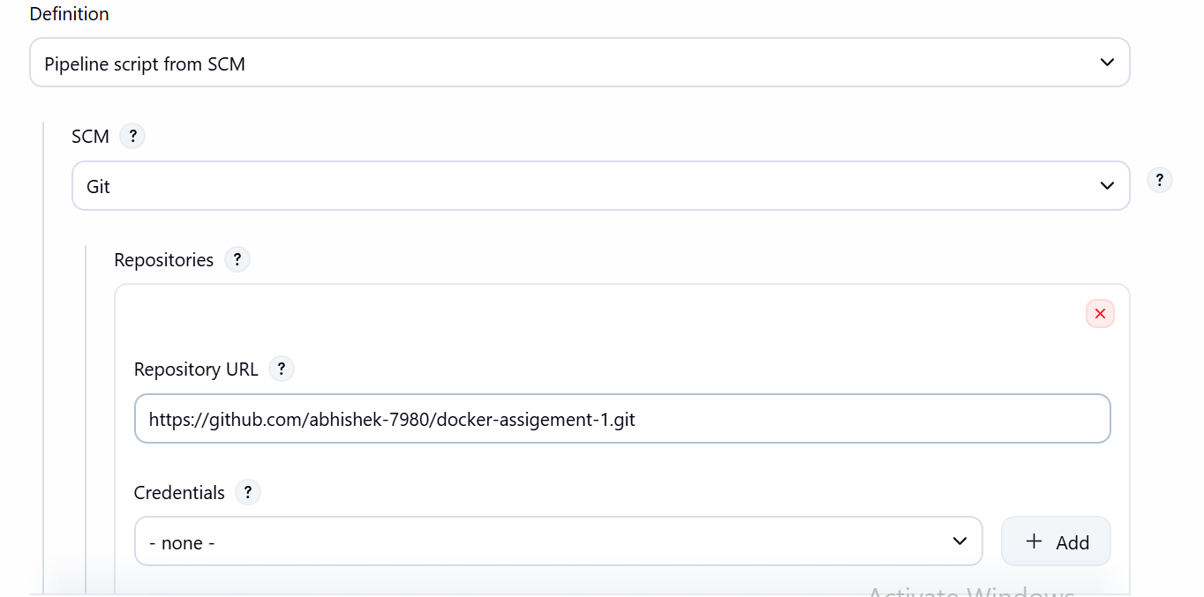

7.Ec2 terminal – container creation and git branch , jenikinsfile loc.
